# 

Rise@Work

Project Plan

|  |
| --- |
| **Team Members** |
| Sam Churney (Team Leader) |
| Aaron Hourie |
| Bray Schurman |
| Negin Sauermann |
| Nicholas McDonald |
| Ruipeng Li |
| Herbert Yanes |

# 

# 

# Master Story List

|  |  |  |  |
| --- | --- | --- | --- |
| **Legend** | | | |
| **Point Value** | **Meaning** |  | **Priority** |
| **1** | **"no sweat” task** |  | High |
| **3** | **"some effort” task** |  | Regular |
| **5** | **"challenging” task** |  | Low |

## 

|  |  |  |
| --- | --- | --- |
| **Priority** | **User Story** | **Effort Required** |
| **1** | As a researcher, I can edit my organization’s consent form and contact details. | **5** |
| **2** | As a researcher, I can decide which maps are visible to participants in my organization by selecting and deselecting them. | **5** |
| **3** | As a researcher, I can download all survey data in an excel spreadsheet. | **3** |
| **4** | As a researcher, I can send and receive emails to and from program participants in my organization. | **1** |
| **5** | As a site administrator, I can edit the content of automated emails sent to users. | **5** |
| **6** | As a site administrator, I can test that the program works by using temporary, artificial user data to see if emails are properly sent, phases can be completed, the proper information is tracked, and that all user interactions and expected uses are functional. | **5** |
| **7** | As a researcher, I can customize which data I wish to download in a  spreadsheet. | **5** |
| **8** | As a site administrator, I can create new organizations and assign researchers by providing the email of a researcher. | **5** |
| **9** | As a researcher, I can manage my own organization’s details. | **3** |
| **10** | As a researcher, I can only view users and download the data of my own organization. | **1** |
| **11** | As a participant, I only have access to my own data. | **1** |
| **12** | As a website user, I can input step logs up to two days back in the event I forget to input the information for that day. | **1** |
| **13** | As a website researcher or administrator, I can skip the sign-up questionnaire with a single click when creating a new account. | **3** |
| **14** | As a site administrator, I can reference a document of training material to remind myself how to make use of site functionality. | **3** |
| **15** | As a user, I can learn to use the website myself through clearly visible buttons and concise help documentation. | **3** |
| **Total Effort:** | | **49** |

# Overview

The overall goal of this project is to improve portability and extend functionality of the current Rise@Work website.

At present, the site is predominantly hard-coded with outdated information, preventing the site from being deployed by the clients themselves or used by other institutions and organizations the clients may work with. A major goal will be to address this issue of portability, with particular emphasis on streamlining and automating the processes of managing the site. This will allow the clients to painlessly configure study-specific consent (consent forms, contact information, etc.) and integrate with as many organizations as necessary.

The second major focus of the project is to expand the feature set to include additional functionality requested by the clients. This includes the ability to: run test programs, to allow the clients to validate the software; manage the site through simple menus, to allow the clients to independently run the site; support a more granular user hierarchy, to allow the clients to control levels of data access; and upgrade to a more robust and customizable method for downloading user data, to meet the clients’ research requirements. Finally, we will generate high-quality documentation for the site, allowing participants and administrators to learn and confidently make use of all features.

The final product will be a stable, fully-featured site ready for deployment and easily scalable to include multiple universities/organizations. The site will be readily extensible by virtue of modular design and internal documentation.

## **Core Release**

Our core release will consist of the six highest priority stories from our master story list. This core release, when completed, will address the client’s main priorities for this project. Below is a list of the stories included in our core release with more detail about their technical requirements.

|  |  |  |
| --- | --- | --- |
| **Priority** | **User Story** | **Effort Required** |
| **1** | As a researcher, I can edit my organization’s consent form and contact details.   * Admin page to upload consent form * Render upload form in iframe with clickable link * Create edit form for research administrators to enter contact information * Reflect changes in the front end templates. | **5** |
| **2** | As a researcher, I can decide which maps are visible to participants in my organization by selecting and deselecting them.   * Create map data model. * Create permission rules for maps and organizations. * Add an edit and delete view. * Replace image link with embedded map | **5** |
| **3** | As a researcher, I can download all survey data in a well-formatted excel spreadsheet.   * Download steps taken in each phase. * Download user survey details. * Download user strategies and achievements. * Reformatting | **3** |
| **4** | ~~As a researcher, I can send and receive emails to and from program participants in my organization.~~   * ~~When webmail is implemented, give clients login information.~~ | **1** |
| **5** | As a site administrator, I can edit the content of automated emails sent to users.   * Create phase email model * Create permission rules for emails, organizations and research admins. * Create all CRUD views and rules. | **5** |
| **6** | As a site administrator, I can test that the program works by using temporary, artificial user data to see if emails are properly sent, phases can be completed, the proper information is tracked, and that all user interactions and expected uses are functional.   * Creates a organization with a temporary usage role.   + Does not contribute to site-wide totals.   + Is only visible to site administrator. * Create a custom view organization view with form for site admin to fill in artificial user data. * Makes use of the Organization, and participant data models. * Artificial user data can be from the future (e.g. Site admin can log user steps from March 1 on Feb 25). | **5** |

## 

## 

## **Site Architecture**

The following diagram is an example of the future site architecture. Beginning from the bottom, participants will belong to one organization (e.g. Dalhousie University). Participants will only be able to contribute to their own organization and they will only be able to see their own information (e.g. step count).

Each organization will require one researcher (e.g. the primary investigator) to manage the participants in the organization as well as the organization’s details. Managing the participants will include: emailing participants with the access code to sign up and join the organization and downloading custom excel sheets for data analysis. Researchers will also be able to manage the organization’s consent form. 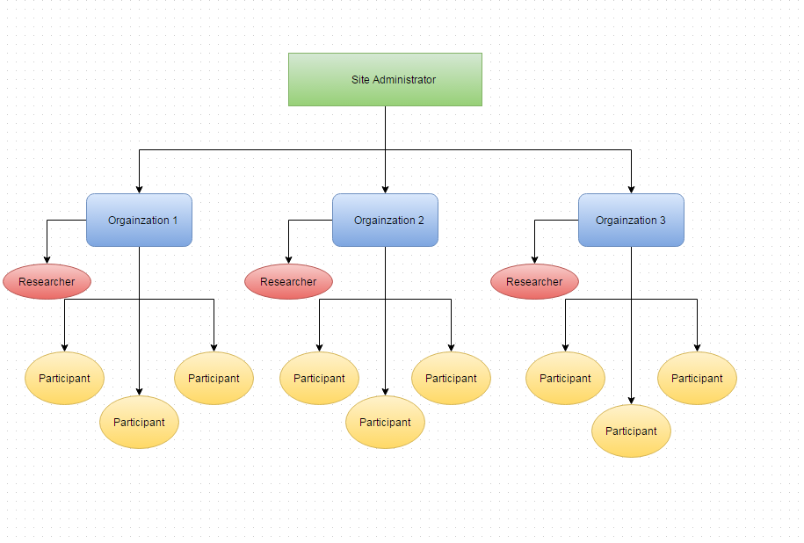

The Site Administrator will be the sole user with the ability to manage all organizations. Managing organizations will include, for example: assigning researchers to organizations and customizing emails sent out to participants for each phase.

# 

# 

## **Burndown Chart**

Below is our initial burndown chart for the project. We expect to deliver 7 points of effort per iteration (therefore, our estimated velocity is 7, highlighted in blue).

Our initial amount of effort remaining is 49. With 7 iterations and 7 points of effort complete per iteration, we will complete all tasks in our master story list within the given schedule (7 iterations).

